# CS 305 Module Five Coding Assignment Checksum Verification Template

## Instructions

Using the instructions from theModule Five Coding Assignment Checksum Verification Guidelines and Rubric, replace the bracketed text with the relevant information in your own words.

## Algorithm Cipher

Using the Java Security Standard Algorithm Names list provided by Oracle I have chosen to use SHA-256.

## Justification

* SHA-256 is an industry standard that is trusted by leading public-sector agencies and is recommended and approved by The National Institute of Standards and Technology.
* There are 2256 possible hash values when using SHA-256, which makes it nearly impossible for two different documents to coincidentally have the exact same hash value.
* The algorithm also uses what is known as the avalanche effect, which means that the hash value is completely changed even if only very minor changes to the original occurs.

(Callaghan, 2020)

## Generate Checksum

You’ll submit your refactored code to your instructor. Your instructor will review it and this document.

## Verification

Insert a screenshot below of the web browser with your unique information.

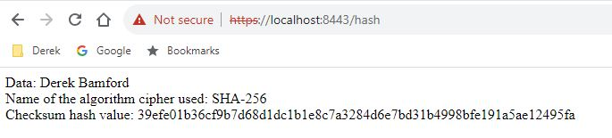

Callaghan, P. (2020, August 19). Why You Should Use SHA-256 in Evidence Authentication. *Pagefreezer*. https://blog.pagefreezer.com/sha-256-benefits-evidence-authentication